**For Sale:**

Second Hand -Inboard Electric Motor and accessories to suit a small-medium sized yacht.

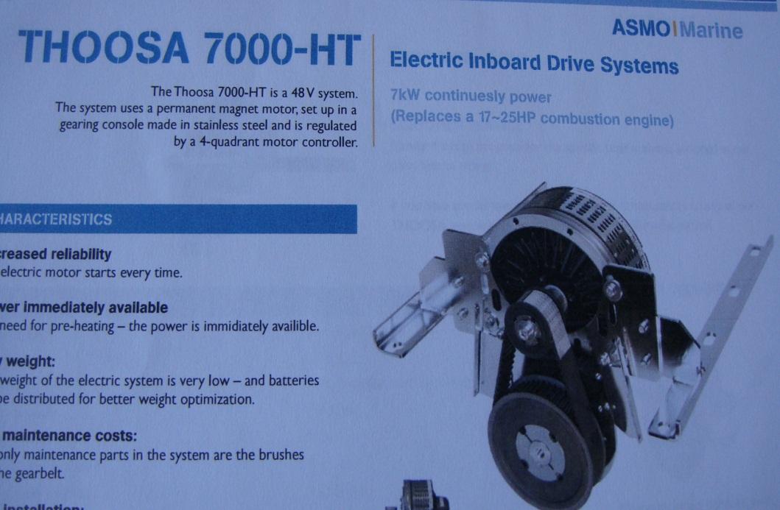

The following motor and accessories are being removed from a vintage 9.8m LOA yacht as part of some restoration works.

The system includes:

* A Thoosa 7000HT electric motor, marketed by ASMO Marine Propulsion Systems.
* Motor and coupling; Throttle unit; Controller; 30A Charger; Link 10 Battery Monitor; Key Switch unit.
* Motor type: Lynch motor, 48V DC, 7.4Kw.
* Total weight 37 Kg.
* 4x 120Ah absorbed glass mat batteries, approximately 5 years old.
* Manuals.

The system was installed new in 2010 and has been used as occasional use auxiliary power. It has had less than 100hrs running time on the Swan River, WA.

It is a neat unit, taking up little space. It is clean and easy to maintain, and runs smoothly. The ASMO 30A charger was replaced, after 14 years of service, in 2024 with a new Lester 30A charger.

The system cost approximately $12,000 (purchase price) in 2010. The Lester charger cost $639 in 2024.

The system as a unit is for sale for $1900. Best offers will be considered. It can be inspected by arrangement, in South Fremantle.

Call Owen, 0411 264 519

